QC Assignment 1

Task 1Q1:

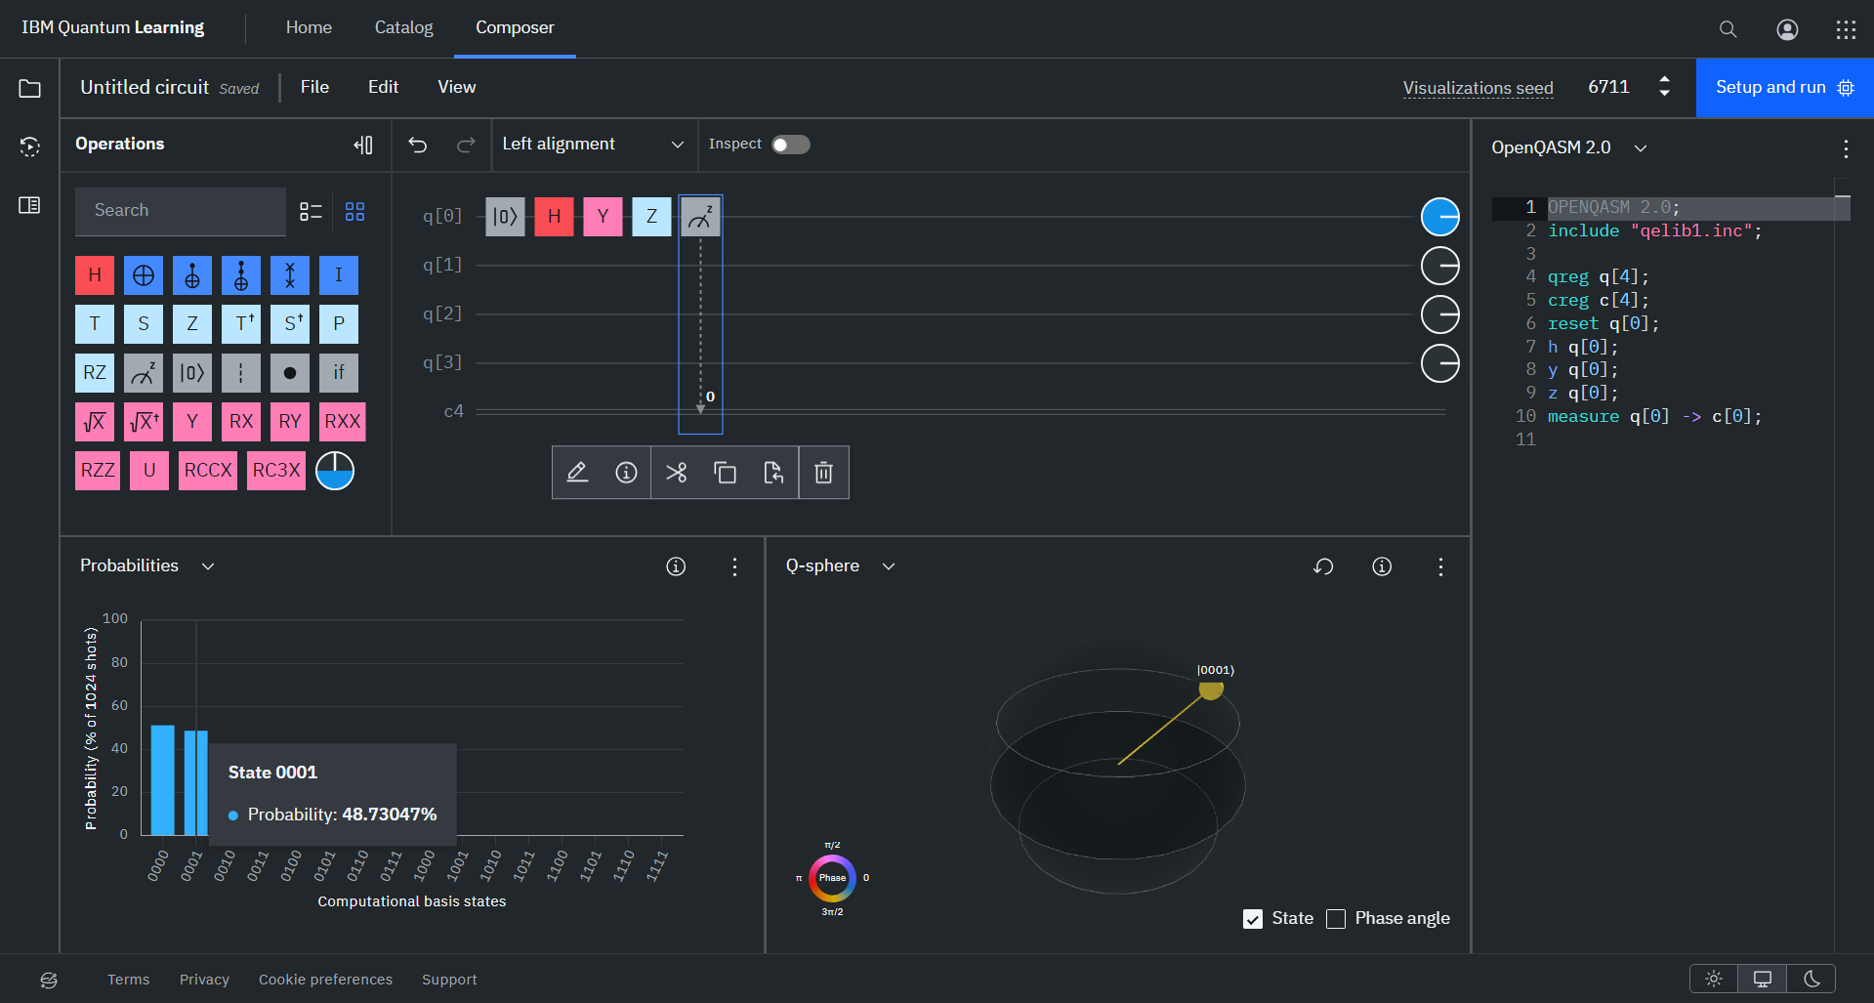

Task 1 Q2:

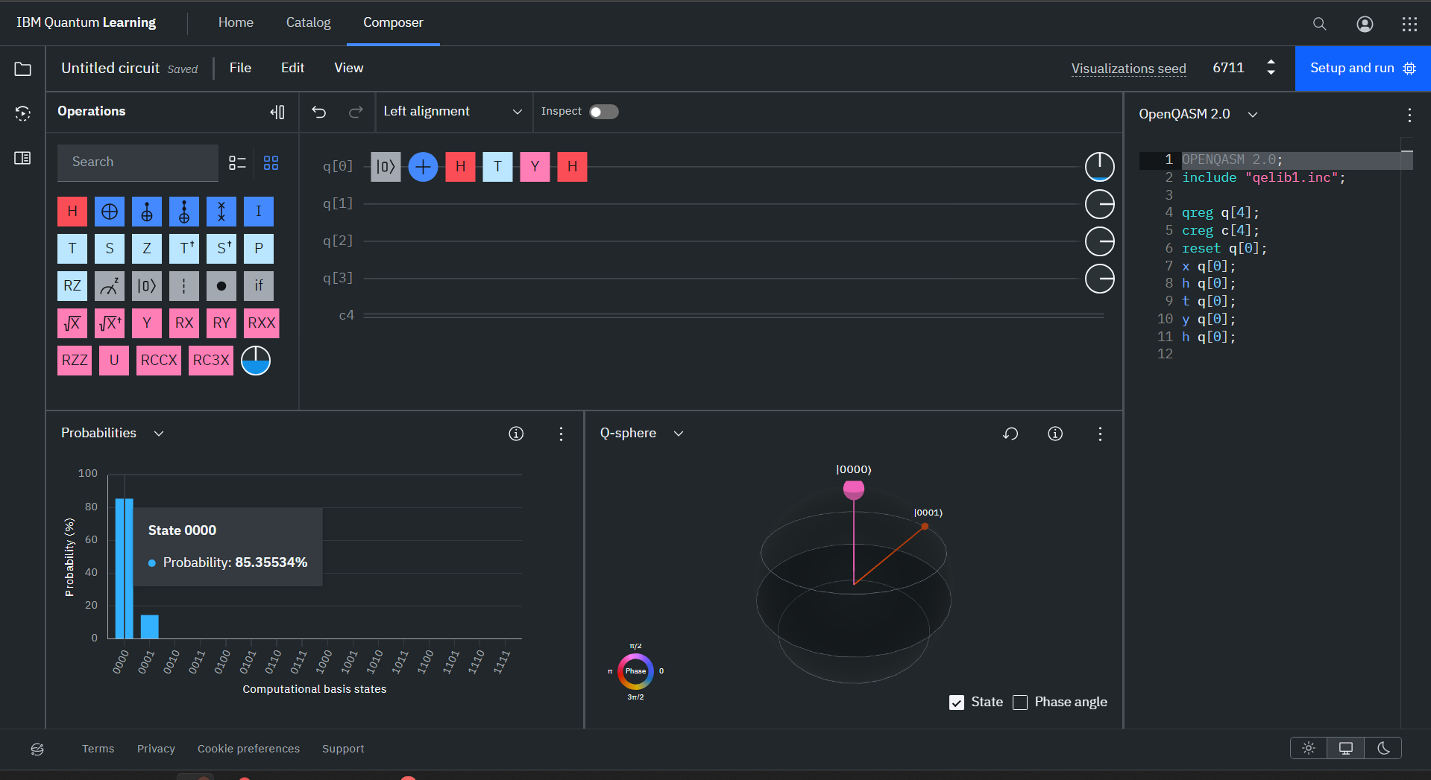

With noise (Z measurement):

Task 1 Q3:

With noise (Z measurement):

Task 1 Q4:

Task1 Q4 (Z gate)

Same answers in both HXH and Z.

Task 1 Q5:

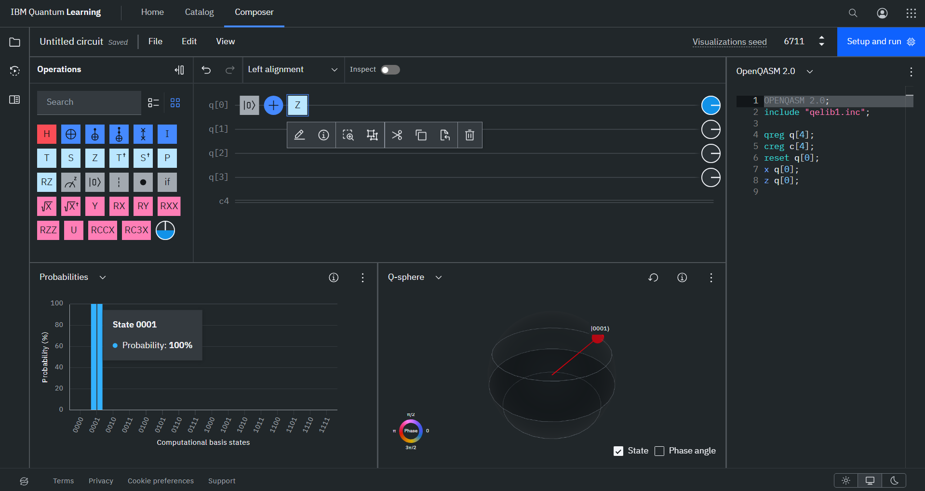

Task 4 Q1:

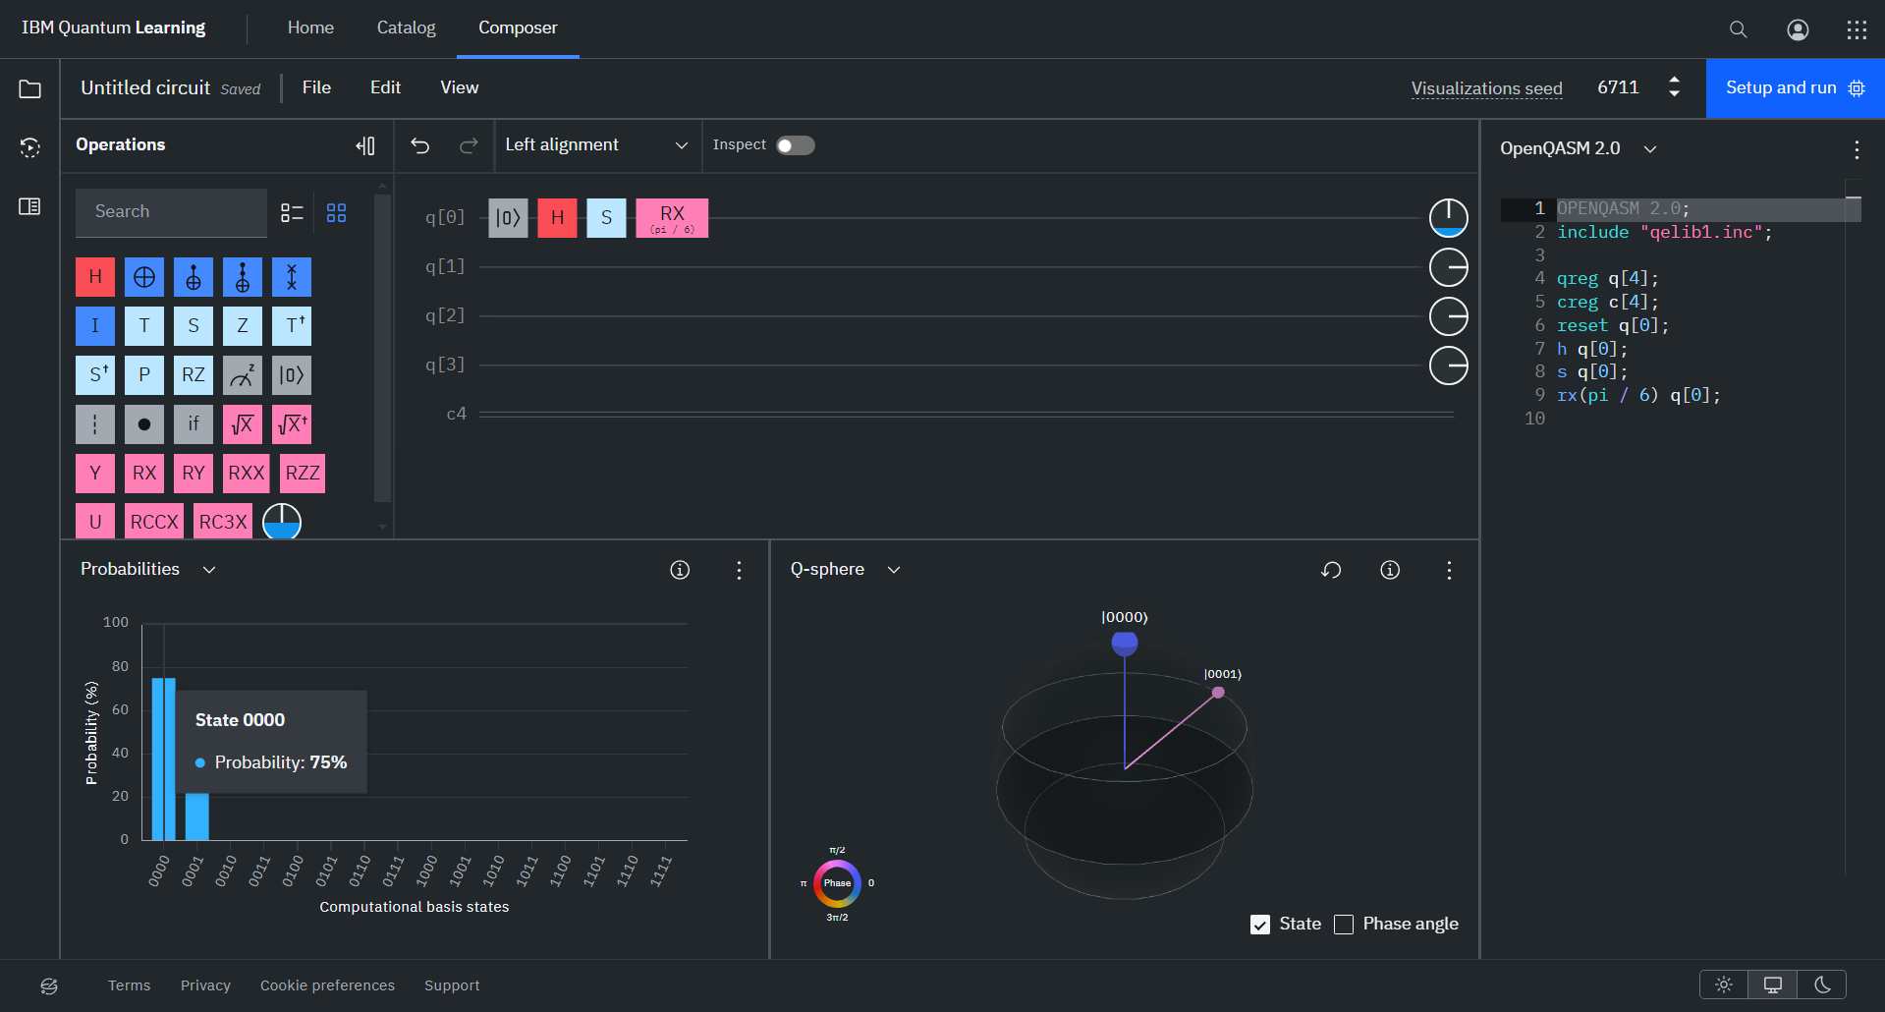

Circuit 2:

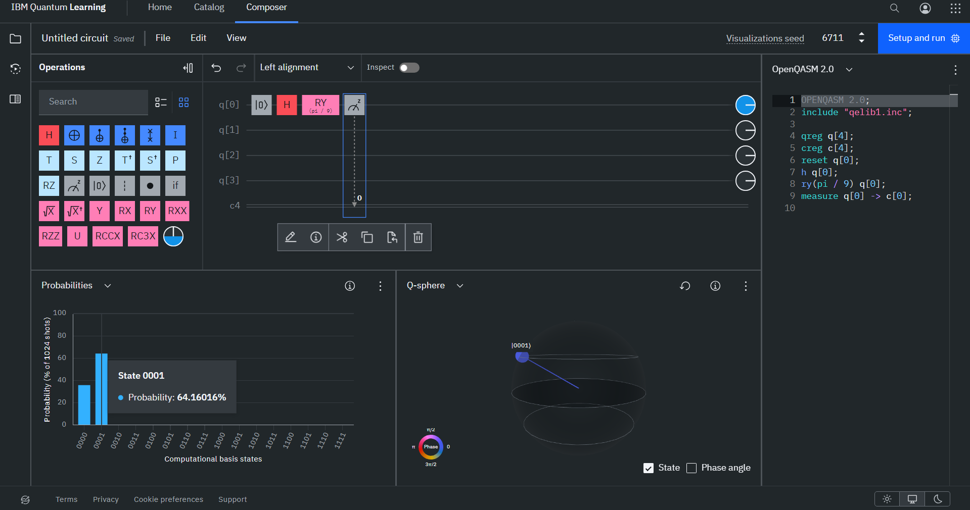

Circuit 3:

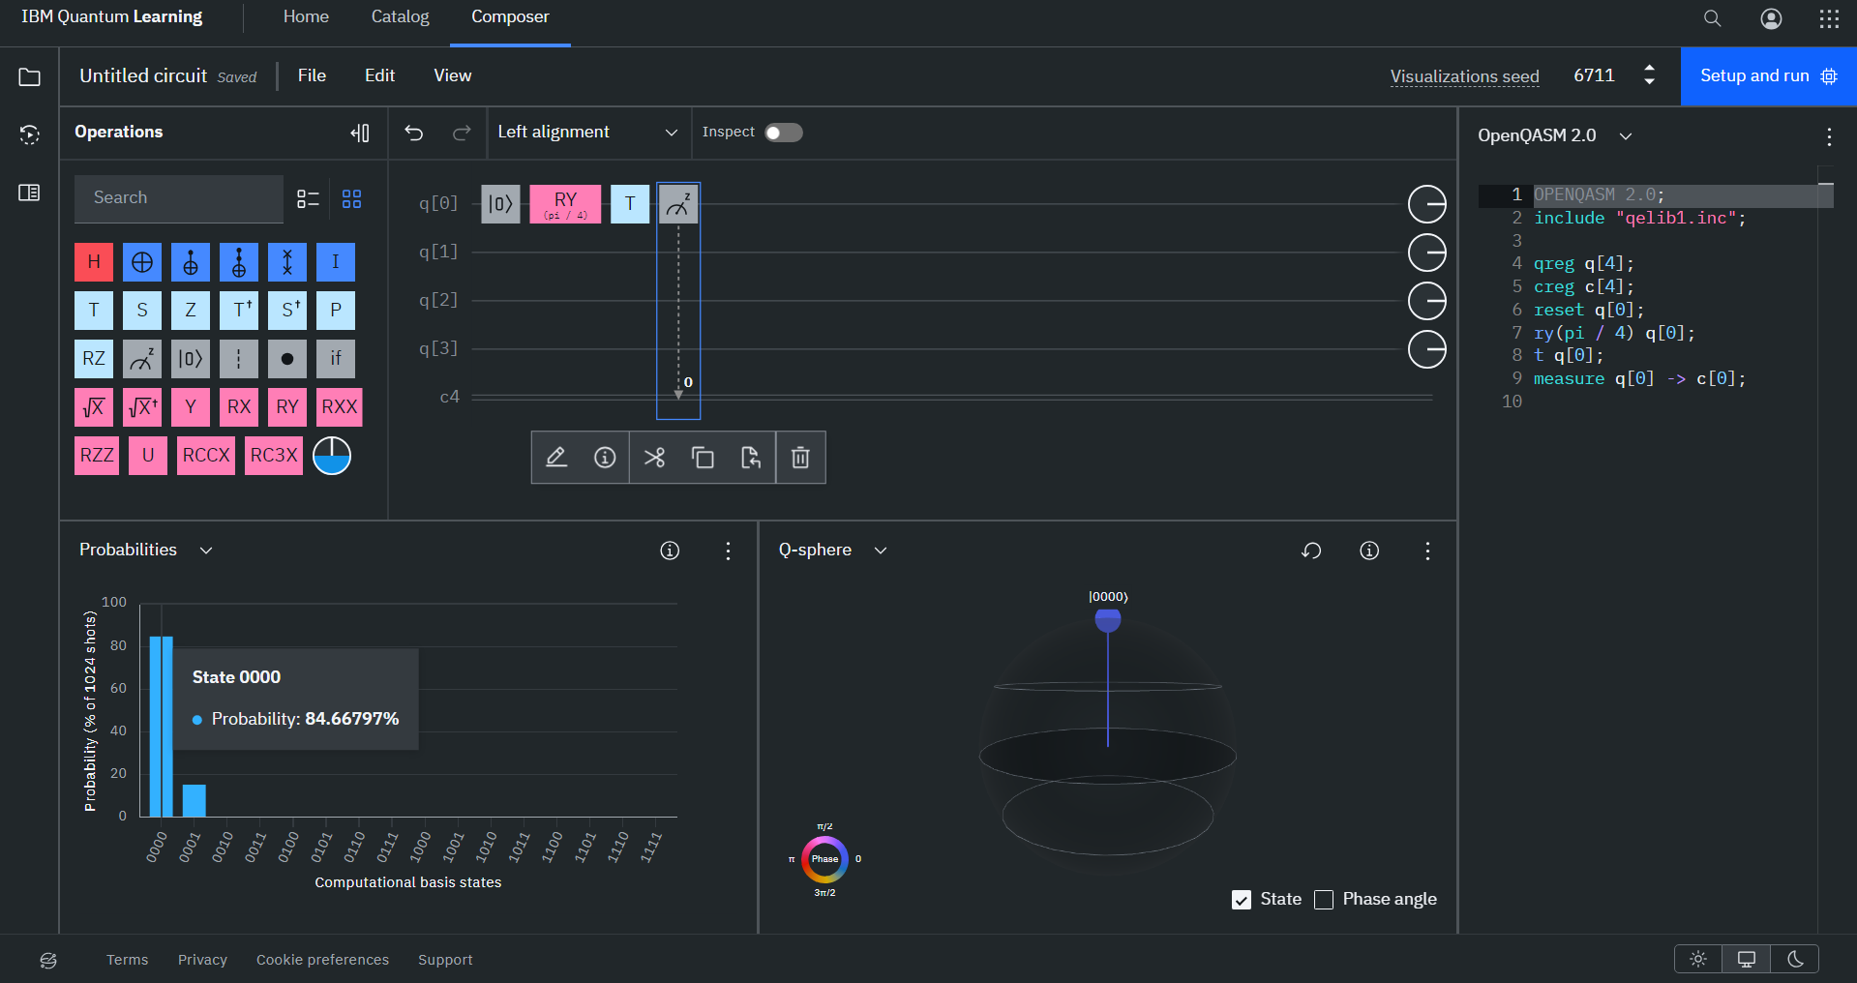

Circuit 4:

Circuit 5:

